**2.2.1: SAS - Residual Diagnostics**

Dr. Bean – Stat 5100

Example: (The Toluca Company data from Handout #2).

**/* Input Toluca data (recall Ch. 1 example) */**

**data toluca; input lotsize workhours @@; cards;**

**80 399 30 121 50 221 90 376 70 361 60 224**

**120 546 80 352 100 353 50 157 40 160 70 252**

**90 389 20 113 110 435 100 420 30 212 50 268**

**90 377 110 421 30 273 90 468 40 244 80 342**

**70 323**

**;**

**run;**

**/* Now fit simple linear model with Y=workhours and X=lotsize,**

**with residuals and predicted values saved in data set**

**tolucaout */**

**proc reg data=toluca;**

**model workhours = lotsize;**

**output out=tolucaout r=resid p=pred;**

**title1 'Simple linear model';**

**run;**

|  |  |  |  |  |  |  |  |  |  |  |  |  |  |  |  |  |  |  |  |  |  |  |  |  |  |  |  |  |  |  |  |  |  |  |  |  |  |  |  |  |  |  |  |  |  |  |  |  |  |  |  |  |  |  |
| --- | --- | --- | --- | --- | --- | --- | --- | --- | --- | --- | --- | --- | --- | --- | --- | --- | --- | --- | --- | --- | --- | --- | --- | --- | --- | --- | --- | --- | --- | --- | --- | --- | --- | --- | --- | --- | --- | --- | --- | --- | --- | --- | --- | --- | --- | --- | --- | --- | --- | --- | --- | --- | --- | --- |
| | **Analysis of Variance** | | | | | | | --- | --- | --- | --- | --- | --- | | **Source** | **DF** | **Sum of Squares** | **Mean Square** | **F Value** | **Pr > F** | | **Model** | 1 | 252378 | 252378 | 105.88 | <.0001 | | **Error** | 23 | 54825 | 2383.71562 |  |  | | **Corrected Total** | 24 | 307203 |  |  |  |      | **Parameter Estimates** | | | | | | | --- | --- | --- | --- | --- | --- | | **Variable** | **DF** | **Parameter Estimate** | **Standard Error** | **t Value** | **Pr > |t|** | | **Intercept** | **1** | 62.36586 | 26.17743 | 2.38 | 0.0259 | | **lotsize** | **1** | 3.57020 | 0.34697 | 10.29 | <.0001 | |

|  |
| --- |
| Panel of fit diagnostics for workhours.  Scatter plot of residuals by lotsize for workhours.Scatterplot of workhours by lotsize overlaid with the fit line, a 95% confidence band and lower and upper 95% prediction limits. |

**/* Look at sequence plot */**

**data temp; set tolucaout;**

**order = _n_;**

**proc sgplot data=temp;**

**series x=order y=resid / lineattrs=(pattern=solid);**

**xaxis label='Order in Data';**

**yaxis label='Residual Value';**

**title1 'Sequence plot of residuals';**

**run;**

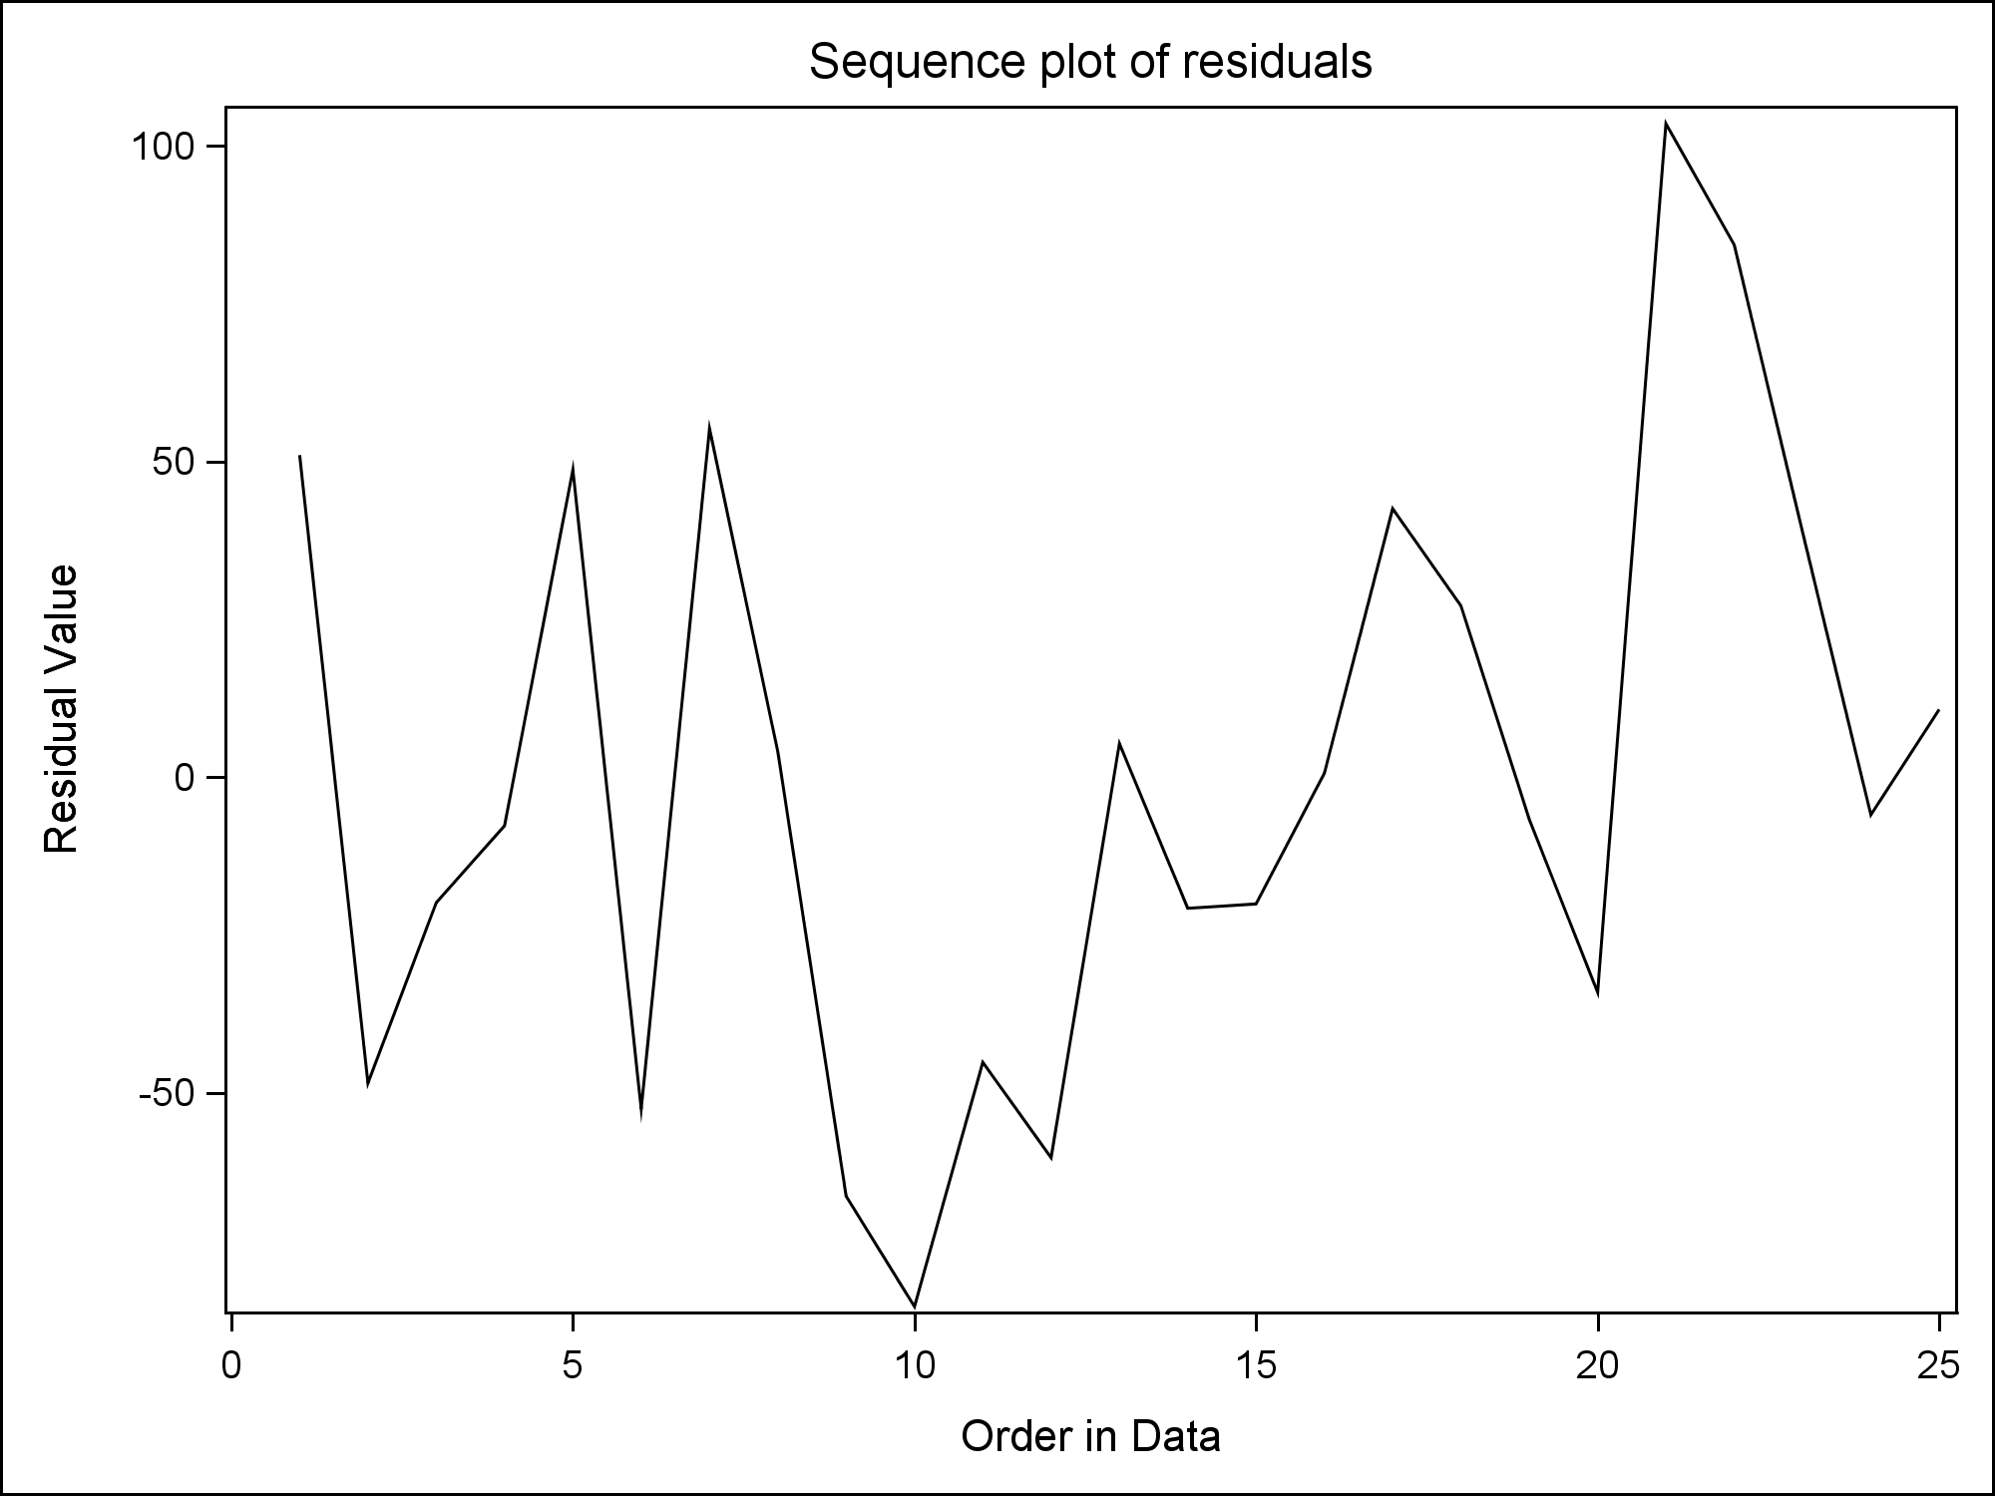

**/************** Numerical Diagnostics *************/**

**/* F-test for lack of fit */**

**proc rsreg data=toluca;**

**model workhours = lotsize / lackfit covar=1 noopt;**

**title1 'F-test for lack of fit';**

**run;**

|  |  |  |  |  |  |  |  |  |  |  |  |  |  |  |  |  |  |  |  |  |  |  |  |  |
| --- | --- | --- | --- | --- | --- | --- | --- | --- | --- | --- | --- | --- | --- | --- | --- | --- | --- | --- | --- | --- | --- | --- | --- | --- |
| | **Residual** | **DF** | **Sum of Squares** | **Mean Square** | **F Value** | **Pr > F** | | --- | --- | --- | --- | --- | --- | | **Lack of Fit** | 9 | 17245 | 1916.069540 | 0.71 | 0.6893 | | **Pure Error** | 14 | 37581 | 2684.345238 |  |  | | **Total Error** | 23 | 54825 | 2383.715617 |  |  | |

**/** Brown-Forsythe and Correlation Test of Normality (shortcut)**

**\*\*/**

**/* Two [unused] ways to access shortcut:**

**filename macrourl "C:\[filepath]\resid_num_diag.sas";**

**%include macrourl;**

**\*/**

**%macro resid_num_diag(dataset,datavar,label= ...**

**/*   
 This resid_num_diag.sas file provides a convenient shortcut**

**to obtaining numerical checks of residuals from**

**a fitted linear regression model.**

**The macro takes five arguments:**

**dataset is the name of the data set**

**datavar is the name of the variable in the data set**

**for which numerical diagnostics are desired**

**(usually a residual)**

**label is a character string for detail in output**

**predvar is the name of the variable (usually predicted**

**value) on which to sort for the Brown-Forsythe test**

**(t-statistic and p-value reported)**

**predlabel is the character string for detail in output**

**related to the predvar variable**

**\*/**

**/* Call the shortcut: */**

**%*resid_num_diag*(dataset=tolucaout, datavar=resid,**

**label='residual', predvar=pred, predlabel='predicted'**);

|  |  |  |  |  |  |  |  |  |  |  |  |  |  |  |  |  |  |  |  |  |  |  |  |  |  |  |  |  |  |  |  |  |  |  |
| --- | --- | --- | --- | --- | --- | --- | --- | --- | --- | --- | --- | --- | --- | --- | --- | --- | --- | --- | --- | --- | --- | --- | --- | --- | --- | --- | --- | --- | --- | --- | --- | --- | --- | --- |
| |  | | --- | | ***P-value for Brown-Forsythe test of constant variance*** | | ***in residual vs. predicted*** |  | **Obs** | **t_BF** | **BF_pvalue** | | --- | --- | --- | | **1** | 1.31648 | 0.20098 |  |  | | --- | | ***Output for correlation test of normality of residual*** | | ***(Check text Table B.6 for threshold)*** |      | **Pearson Correlation Coefficients, N = 25  Prob > |r| under H0: Rho=0** | | | | --- | --- | --- | |  | **resid** | **expectNorm** | | |  | | --- | | **resid** | | residual | | |  | | --- | | 1.00000 | |  | | |  | | --- | | 0.99151 | | <.0001 | | | |  | | --- | | **expectNorm** | |  | | |  | | --- | | 0.99151 | | <.0001 | | |  | | --- | | 1.00000 | |  | | |